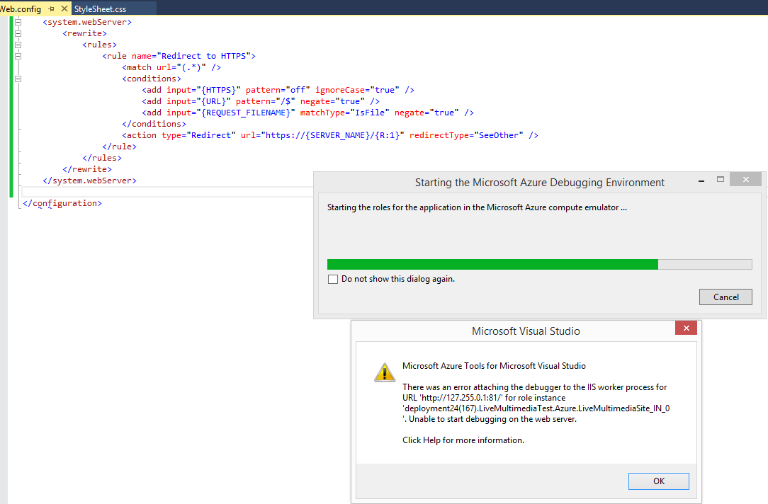

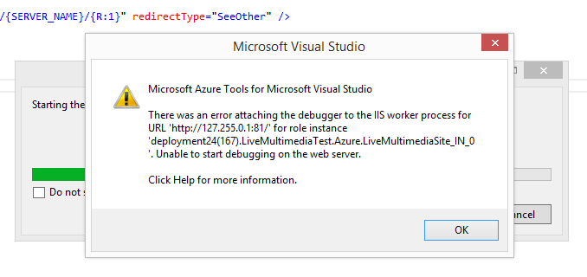

<system.webServer>

<rewrite>

<rules>

<rule name="Redirect to HTTPS">

<match url="(.*)" />

<conditions>

<add input="{HTTPS}" pattern="off" ignoreCase="true" />

<add input="{URL}" pattern="/$" negate="true" />

<add input="{REQUEST_FILENAME}" matchType="IsFile" negate="true" />

</conditions>

<action type="Redirect" url="https://{SERVER_NAME}/{R:1}" redirectType="SeeOther" />

</rule>

</rules>

</rewrite>

</system.webServer>

<rewrite>

<rules>

<rule name="RedirectToHTTPS" stopProcessing="true">

<match url="(.*)" />

<conditions>

<add input="{HTTPS}" pattern="off" ignoreCase="true" />

</conditions>

<action type="Redirect" url="https://{SERVER_NAME}/{R:1}" redirectType="SeeOther" />

</rule>

</rules>

</rewrite>

</system.webServer>

<system.webServer>

<rewrite>

<rules>

<rule name="Redirect to HTTPS">

<match url="(.*)" />

<conditions>

<add input="{HTTPS}" pattern="off" ignoreCase="true" />

<add input="{URL}" pattern="/$" negate="true" />

<add input="{REQUEST_FILENAME}" matchType="IsFile" negate="true" />

</conditions>

<action type="Redirect" url="https://{SERVER_NAME}/{R:1}" redirectType="SeeOther" />

</rule>

</rules>

</rewrite>

</system.webServer>

<system.webServer>

<rewrite>

<rules>

<rule name="Redirect to HTTPS" stopProcessing="true">

<match url="(.*)" />

<conditions>

<add input="{HTTPS}" pattern="^OFF$" />

</conditions>

<action type="Redirect" url="https://{SERVER_NAME}/{R:1}" redirectType="Found" />

</rule>

</rules>

</rewrite>

</system.webServer>

Предложено в answers и работает только в Release:

<system.webServer>

<validation validateIntegratedModeConfiguration="false" />

<rewrite>

<rules>

<rule name="Redirect HTTP to HTTPS" stopProcessing="true">

<match url="(.*)"/>

<conditions>

<add input="{HTTPS}" pattern="^OFF$"/>

</conditions>

<action type="Redirect" url="https://{HTTP_HOST}/{R:1}" redirectType="SeeOther"/>

</rule>

</rules>

</rewrite>

</system.webServer>

Комплекс правил

---------------------------------------------------------------------------------------------------------------------------------------------

<rule name="CanonicalHostNameRuleWithHTTPS">

<match url="(.*)" />

<conditions>

<add input="{HTTP_HOST}" pattern="^www\.jetsas\.com$" negate="true" />

<add input="{URL}" negate="true" pattern="\.axd$" />

</conditions>

<action type="Rewrite" url="https://www.jetsas.com/{R:1}" />

</rule>

<rule name="Default Document" stopProcessing="false">

<match url="(.*?)/?Default\.aspx$" />

<conditions>

<add input="{URL}" negate="true" pattern="\.axd$" />

</conditions>

<action type="Rewrite" url="{R:1}/" />

</rule>

<rule name="Lower Case URLs" stopProcessing="false">

<match url="[A-Z]" ignoreCase="false" />

<conditions logicalGrouping="MatchAll" trackAllCaptures="false">

<add input="{URL}" negate="true" pattern="\.axd$" />

</conditions>

<action type="Rewrite" url="{ToLower:{URL}}" />

</rule>

<!-- Comment below for debugging in local computer -->

<rule name="Trailing Slash" stopProcessing="true">

<match url="(.*[^/])$" />

<conditions logicalGrouping="MatchAll" trackAllCaptures="false">

<add input="{REQUEST_FILENAME}" matchType="IsDirectory" negate="true" />

<add input="{REQUEST_FILENAME}" matchType="IsFile" negate="true" />

<add input="{URL}" negate="true" pattern="\.axd$" />

</conditions>

<action type="Rewrite" url="{R:1}/" />

</rule>

<rule name="Redirect HTTP to HTTPS" stopProcessing="true">

<match url="(.*)" />

<conditions>

<add input="{HTTPS}" pattern="off" ignoreCase="true" />

<add input="{URL}" pattern="/$" negate="true" />

<add input="{REQUEST_FILENAME}" matchType="IsFile" negate="true" />

<add input="{URL}" negate="true" pattern="\.axd$" />

</conditions>

<action type="Redirect" url="https://{HTTP_HOST}/{R:1}" redirectType="SeeOther" />

</rule>

---------------------------------------------------------------------------------------------------------------------------------------------